APB Consultancy LTD.

Northwest Construction Capstone Project

Project Design Document

**BUSINESS HISTORY**

|  |  |  |  |  |
| --- | --- | --- | --- | --- |
| DATE | **VERSION** | **NAME** | **ORG.** | **COMMENTS** |
| 18/04/2024 | **1.0** | *Corey Aherne* | **ABP INC.** | First draft |
| 25/04/2024 | **2.0** | *Eóin Dooley* | **ABP INC.** | Final draft |

**DOCUMENT APPROVAL FLOW**

|  |  |  |  |  |  |
| --- | --- | --- | --- | --- | --- |
| **VERSION** | **FLOW** | **ROLE** | **NAME** | **ORG.** | **DATE** |
| **1.0** | **PREPARED BY** | **BUSINESS ANALYST** | *Corey Aherne* | **ABP INC.** | **18/04/2024** |
| **2.0** | **EDITED BY** | **SME** | *Eóin Dooley* | **ABP INC.** | **25/04/2024** |

**TABLE OF CONTENTS**

1. **Introduction**

**1.1** Purpose of the document

**1.2** Objectives

**1.3** NECESSARY PRE-REQUISITES FOR AUTOMATION

1. **AS IS PROCESS DESCRIPTION**

**2.1** High-Level Description

**2.2** Low-Level Description

**3. TO BE PROCESS DESCRIPTION**

**3.1** TO BE DETAILED PROCESS MAP

**3.1.1** GRASP

**3.1.2** YIELD

**3.1.3** GRASP 2

**3.1.4** YIELD 2

**3.2** LOW-LEVEL PROCESS OVERVIEW

**4. ERROR HANDLING & TOS**

**4.1.1** In Scope for RPA

**4.1.2** Out of Scope for RPA

**4.1.3** Business Exceptions Handling

**4.2 UNKNOWN EXCEPTIONS**

**4.2.1** Application Error and Exception Handling

**4.3 UNKNOWN ERRORS AND EXCEPTIONS**

**5. OTHER**

**5.1** ACRONYMS

1. **INTRODUCTION**

**1.1 PURPOSE OF THE DOCUMENT**

The Process Design Document outlines the process of finding and categorizing the items that have been chosen for automation, namely, the invoices received by Northwest Construction Ltd.

The document describes the sequence of steps to be performed as a part of the business process, the specific conditions and rules that must be obeyed. This document serves as a base for the developers, providing them with the necessary details to develop a robotic automation process for the selected business process.

**1.2 OBJECTIVES**

The business objectives for Northwest Construction expected by the Business Process Owner after automation of the selected business process are:

|  |  |
| --- | --- |
| **OBJECTIVES** | **BENEFITS** |
| **Reduce the repetitive tasks** | Reduce workload, freeing up Accounts Payable staff for more value-add-related tasks. |
| **Streamlined process** | Faster process, to the benefit of Northwest’s vendors. |
| **Standardize Automation** | Removes human error which would need correction otherwise. |

**1.3 NECESSARY PRE-REQUISITES FOR AUTOMATION**

* Complete Process Definition Document with As-is and To-Be solution signed by relevant parties.
* Test Data to support development
* Acquire the necessary user access and accounts (licenses, permissions, user accounts)
* Necessary credentials required to logon the machines and applications

1. **AS IS PROCESS DESCRIPTION**

|  |  |  |
| --- | --- | --- |
| 1 | Process full name | Invoice Processing |
| 2 | **Process Area** | Technical Solutions |
| 3 | **Department** | Banking & Finance |
| 4 | **Process short description**  (operation, activity, outcome) | The employee examines new emails containing invoices, downloads and analyses these invoices, verifies the information contained therein, and then creates an invoice in Northwest’s custom system. The automation solution is to cover all aspects of this process. |
| 5 | **Role(s) required for performing the process** | **Product Owner** - Responsible for defining the features and capabilities of the automated loan and account creation process. **Business Analyst (BA)** - Analyzes and documents all requirements for the automated process, making sure that all of the process is in line with business goals and the users needs. **RPA Developer** - Develops the automation code. |
| 6 | **Process schedule and frequency** | The bot will run every working day, at ten-minute intervals It is expected that this process will be required daily. |
| 7 | **# of items processes /reference period** | Approximately 200 invoices are processed per day, with ~3200 in a given month. |
| 8 | **Average handling time per item** | ~5min with 1-3min variance |
| 9 | **Peak period (s)** | (Morning)9:00am – 11:00am (Lunch)12:00pm – 1:00pm (Afternoon) 2:00pm – 4:00pm |
| 10 | **Transaction Volume During Peak period** | Increase of 15-17% |
| 11 | **Total # of FTEs supporting this activity** | ~5 FTE |
| 12 | **Expected increase of volume in the next reference period** | 10% |
| 13 | **Level of exception rate** | 2% |
| 14 | **Input data** | Invoice |
| 15 | **Output data** | Confirmation of invoice in system |

**AS IS PROCESS STEPS**

|  |  |  |
| --- | --- | --- |
| Step | Description | Details (Screenshot) |
| 1 | check for new invoice email |  |
| 2 | move to appropriate subfolder |  |
| 3 | Open invoice and verify details match the PO details in the Procedural System |  |
| 4 | Create an invoice in Procedural System |  |
| 5 | Wait for Accounts Payable Team to approve the invoice |  |

**AS IS DETAILED PROCESS MAP**

**HIGH-LEVEL PROCESS OVERVIEW:**

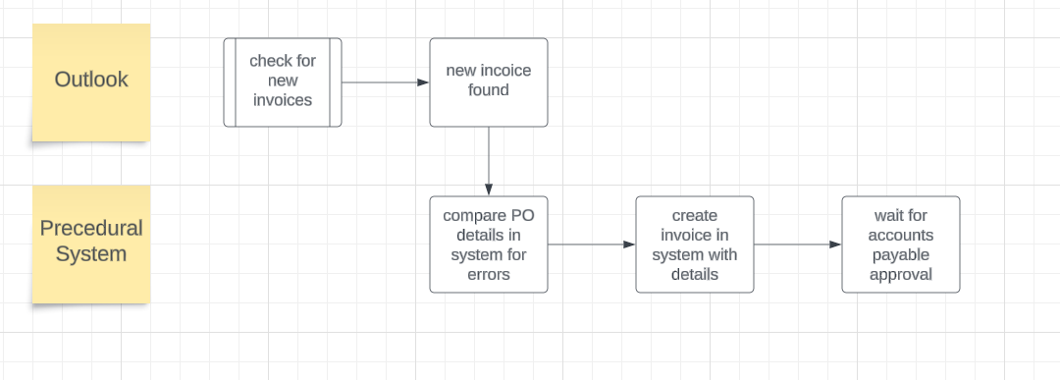

Broken down by component

GRASP:

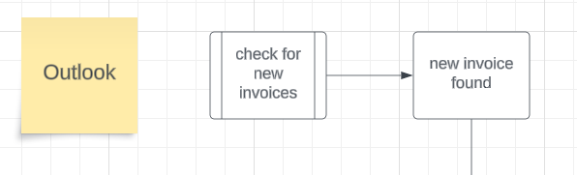

Yield:

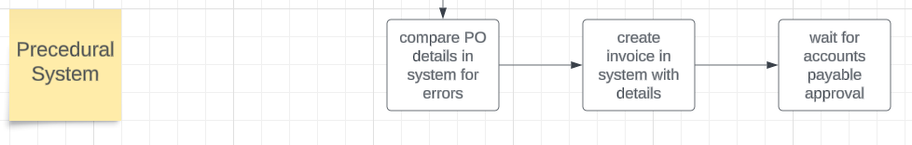

**LOW-LEVEL PROCESS OVERVIEW:**

**Grab Invoice Email From Outlook**

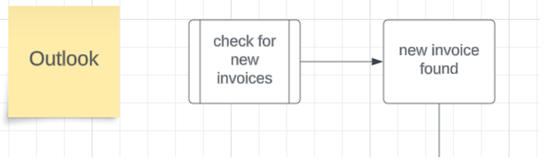

**Compare details in Procedural System:**

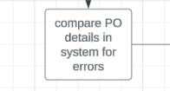

**Create invoice in system with all details:**

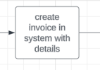

**3. TO BE PROCESS DESCRIPTION**

This chapter highlights the expected design of the business process after automation.

The robot will first check a designated Outlook email account for new emails. If it finds a PDF attachment, it will assume it is an invoice and begin processing it accordingly. It will download both the email and the attachment, storing them in vendor-specific folders, and it will relocate the email within the email account. It will read the downloaded invoice for specific pieces of information necessary for invoice creation. Once it has extracted the required information, it will proceed to invoice creation.

During invoice creation, the robot will follow all the steps outlined in the as-is process. It will verify all information first, including payment method, line items if materials were purchased, as well as total payments to be made. Once everything is verified, it will input the necessary data. If there is an imbalance between the purchase order total and the full invoice amount, the invoice will be marked as partially closed, else, it will be marked fully closed and passed to the UiPath Action Centre for human verification.

**3.1 TO BE DETAILED PROCESS MAP**

**HIGH-LEVEL PROCESS OVERVIEW**

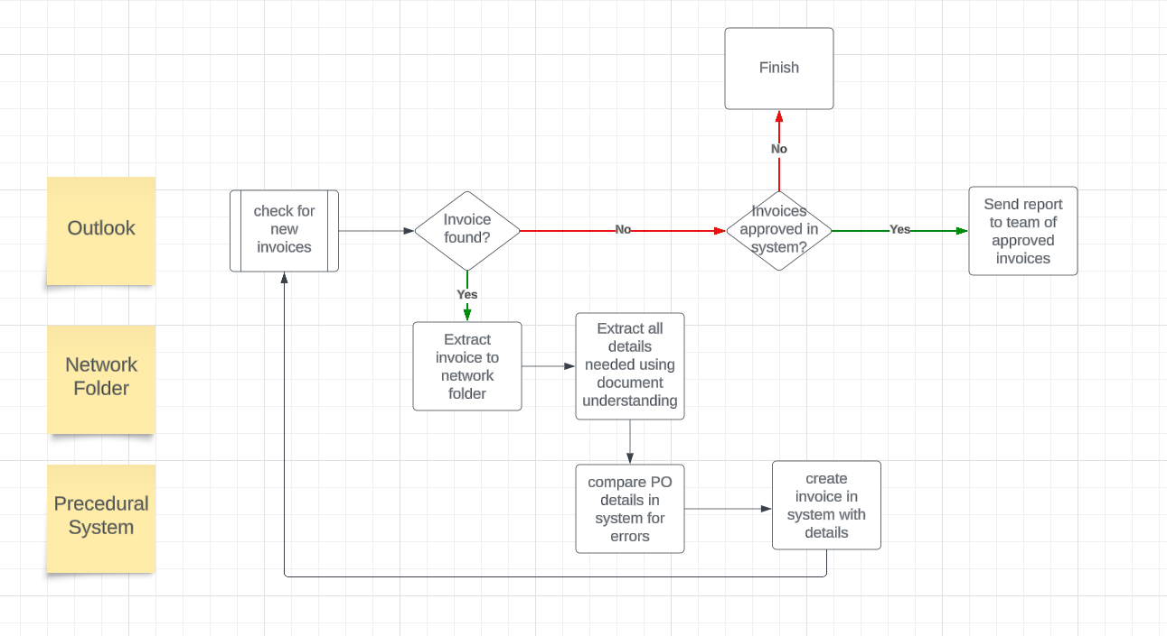

Broken down by component.

**3.1.1**

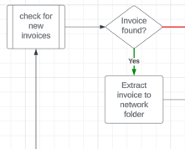

**3.1.2**

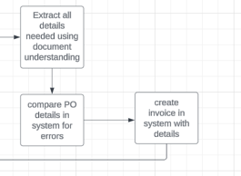

**3.1.3**

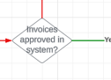

**3.1.4**

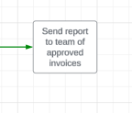

**3.2 LOW-LEVEL PROCESS OVERVIEW:**

**Grab Invoice Email from Outlook:**

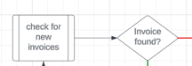

**Extract to Share Folder & all details using Document Understanding:**

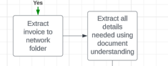

**Compare PO to details in procedural System:**

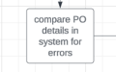

**Create Invoice in System:**

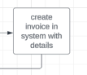

**Check for approvals and send email report If so:**

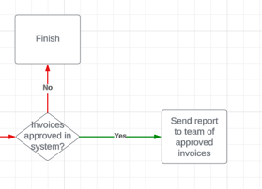

**4. Error Handling & TOS**

**4.1.1 In Scope for RPA**

The automated process will be developed as described in this document.

**4.1.2 Out of Scope for RPA**

The following will be considered out of scope for this automated process:

· N/a

**4.1.3 Business Exceptions Handling**

**Known Exceptions**

Currently there are no known exceptions.

**4.2 Unknown Exceptions**

**For all the other unanticipated or unknown business (process) exceptions, the robot should:**

· Take a screenshot and save locally.

· Send an error log message

· Recover & retry for maximum 3 times

· Close the applications and run the sequence again

**4.2.1 Application Error and Exception Handling**

**Known Errors or Exceptions**

The table below reflects all the errors identifiable in the process evaluation and documentation.

For each of these errors or exceptions, define a corresponding expected action that the robot should complete if it is encountered.

|  |  |  |  |
| --- | --- | --- | --- |
| Error Name | **Step** | **Parameters** | **Action** to be taken |
| Application crash/Internal error | Any | Error message | Recover & retry for maximum 3 times.  Take Screenshot.  Close the applications and run the sequence again. |
| Timeouts | Any | Error message | Recover & retry for maximum 3 times.    Take Screenshot.  Close the applications and run the sequence again. |

**4.3 Unknown Errors and Exceptions**

**For all the other unanticipated or unknown business (process) exceptions, the robot should:**

· Take a screenshot and save locally.

· Send an error log message

· Recover & retry for maximum 3 times

· Close the applications and run the sequence again

**5. OTHER**

**5.1** Acronyms

|  |  |
| --- | --- |
| **Abbreviation** | **Full-length** |
| **ABP INC.** | **Agile Business Processing Incorporated** |